**Step 1:**

Social Statistics section (This was the most relevant category. Sesa had mentioned that they will put us into another category, if deemed more appropriate)

**Step 2:**

Which one should I choose?

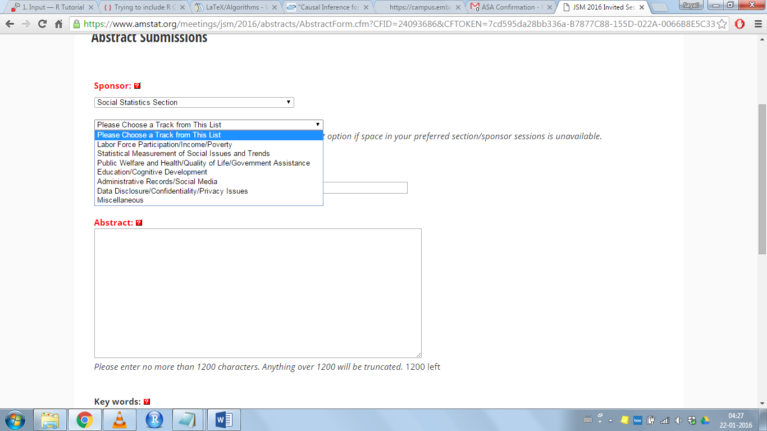

**Step 3:**

**Title:** Interference in field experiments

**Step 4:**

**Abstract:** no more than 1200 characters

**Step 5:**

Upto 6 keywords/phrases (**Please suggest**)

Causal inference, networks, interference between units, randomized experiments

**Step 6:**

Do we give permission to change it to a poster or speed?

Description of a speed session as quoted from the website:

“Speed sessions are a "hybrid" of a poster and presentation. A speed session consists of 20 oral presentations of five minutes each, with 10 minutes of break after the first set of 10 talks. The short oral presentations are then followed by an e-poster (offered on a 42" LCD display in the landscape position) session later the same day.”

**Step 7:**

Details required for author:

**Name:** Bruce

**Surname:** Desmarais

**Organization:** Pennsylvania State University

**Address:** Optional

**Phone number:** Required

**Email:** [bdesmarais@psu.edu](mailto:bdesmarais@psu.edu)